DST Assignment John Agbulos 3030429

# State Diagram

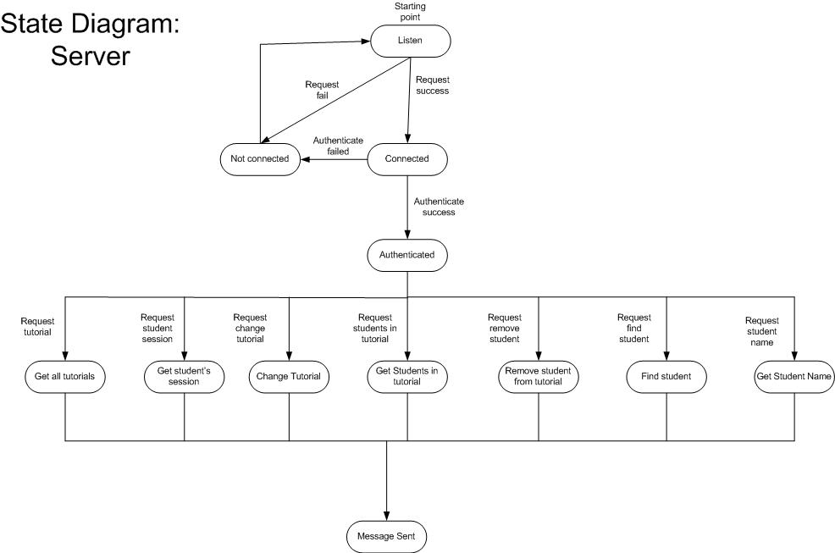

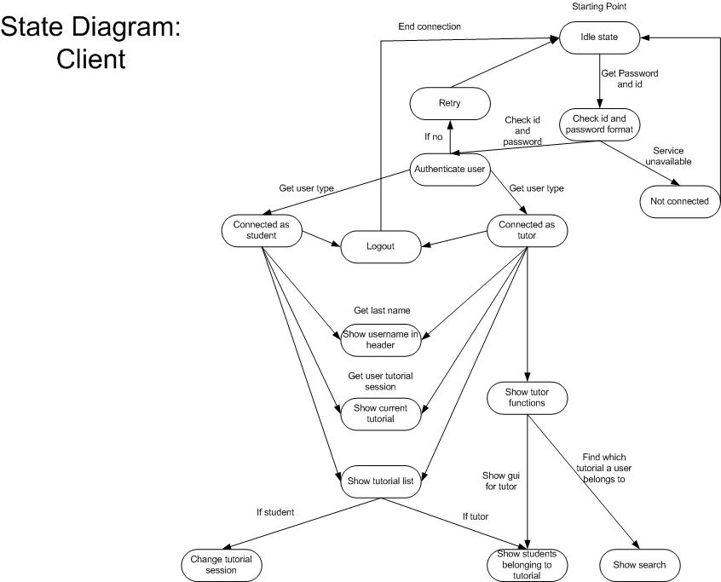

Part A Question 1

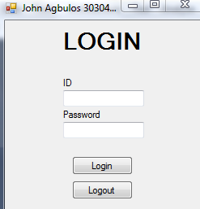

When the program is started the first user interface contains an option to put the users ID and password respectively called txt_ID and txt_Password.

Part A Question 2

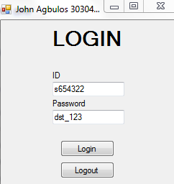

When the “Login” button is pressed before a connection is actually made the format of the id and the password has to be checked first using the following code.

string IDRegex = @"[su]\d{6}$";

string staff_IDRegex = @"[s]\d{6}$";

string student_IDRegex = @"[u]\d{6}$";

string passwordRegex = @"[!@#$%^&*()_+=\[{\]};:<>|./?,\\'""-0123456789]";

The regex checks the format of the code. Staff_IDRegex checks if the login begins with “U”. The passwordregex checks if the password contains a non alphabetic character

Part A Question 3

Once the logins have been checked for proper formatting a connection is established with the server.

public void connectToServer(string loginType)

{

try

{

serPort = 1234;

serName = Dns.GetHostName();

serIP = Dns.GetHostAddresses(serName)[0];

connection = new TcpClient(serName, serPort);

stream = connection.GetStream();

sendLogin();

initializeReader();

if (loginType == "staff")

{

txt_Search.Visible = true;

cmd_Search.Visible = true;

lst_Students.Visible = true;

cmd_Remove.Visible = true;

}

}

catch (Exception ex)

{

MessageBox.Show("Connection error, Please try again");

}

}

The method connectToServer establishes a connection with a server. In the server there is a database listener which will detect an incoming connection. The class SerListener in the server program listens to any attempts of connection.

Part A Question 4

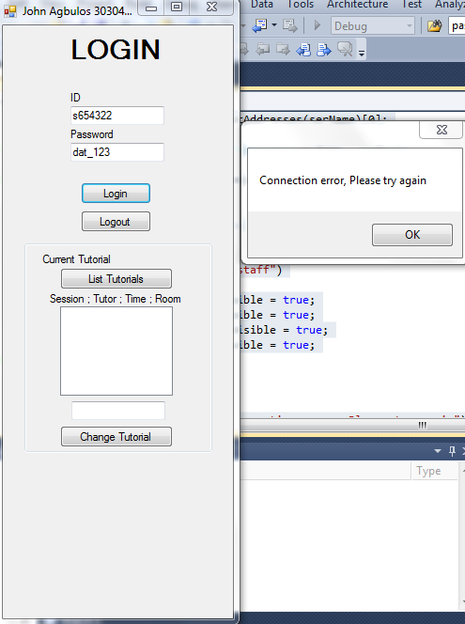

This screenshot is an attempt to connect to the server when the server is not running. The user will be prompted with an error asking them to retry.

Part A Question 5

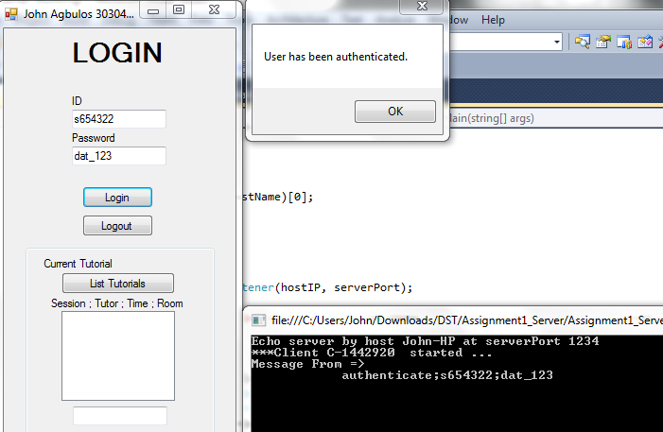

Once the connection has been established a message is sent to the server with the username and password pair. The format for the message is Function, username, password. The user is then authenticated.

Part A Question 6

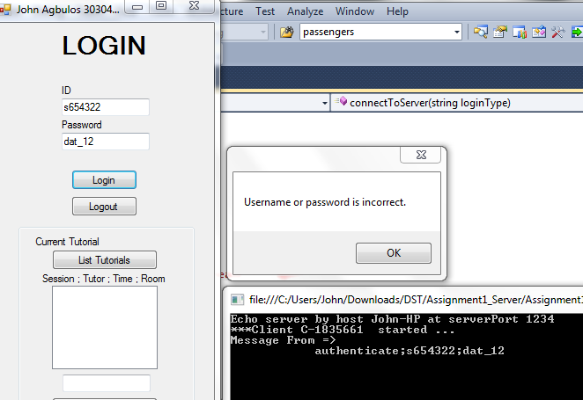

Screenshot of when a user types in the wrong password. The server returns an error message which lets the user know that the password or username is incorrect.

Part A Question 7

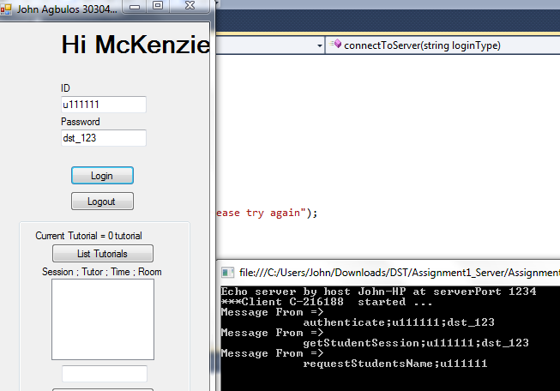

If a student logs in the title on the top greats the user using his/her last name. The current tutorial is also shown that the student is enrolled in. The user must press on the Current tutorial label to get the current tutorial and the name. A logout button is always present. But when there is no connection to server it does nothing. Once the user is logged in he/she can choose to logout.

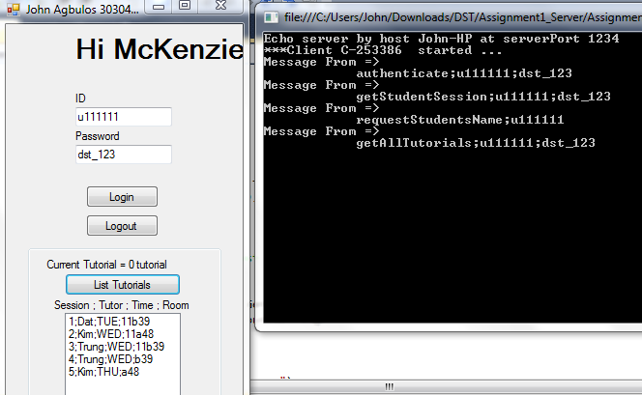

The user can press list tutorials button in order to populate the listbox of the current available tutorials. Once the listbox is populated the user can change to the selected tutorial by pressing the change tutorial button.

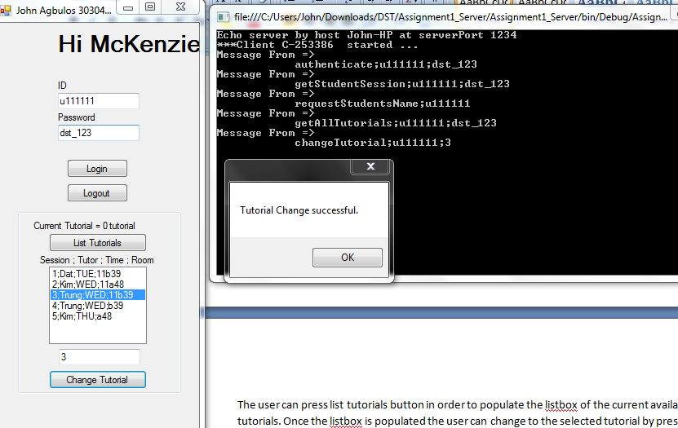

Question A Part 9

If the user chooses to logout an EOB message is sent to the server to end the connection

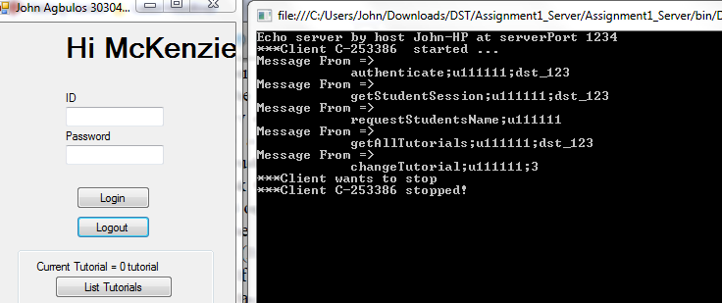

Question A Part 10

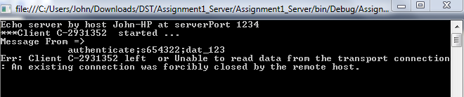

If the user is disconnected unexpectedly the client is notified that there is a connection error and closes the connection.

Part B Question 11

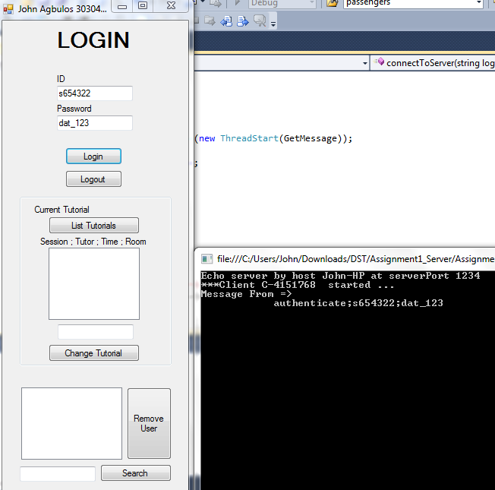

When a staff member logs in and is authenticated extra features at the bottom are shown. It is a listbox which shows the users which are enrolled in the tutorial selected.

Part B Question 12

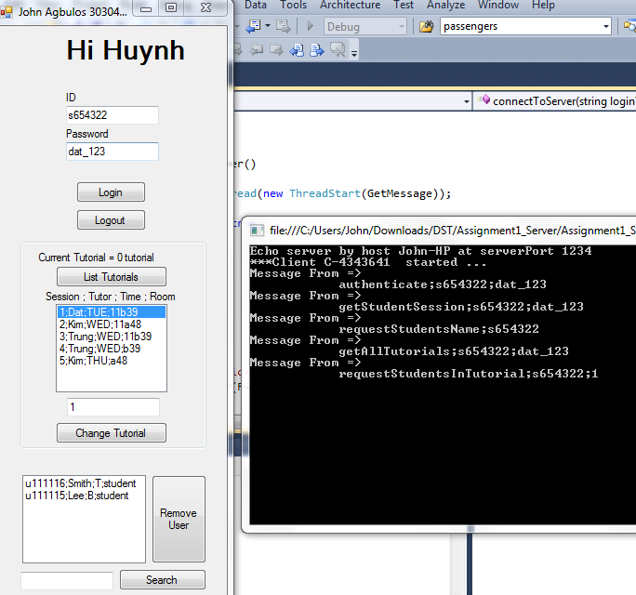

If the a tutorial in the listbox is selected the program gathers all the students who are enrolled into that class. The students contain username, lastname, initial and user class.

Part B Question 13

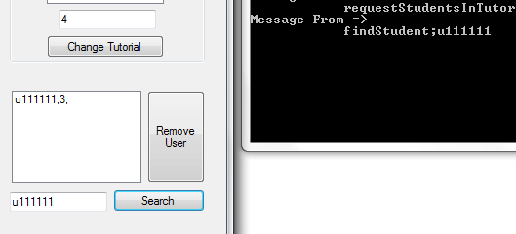

A tutor can also search for a student by entering their username into the search text box and pressing the search button. It will show the username and the tutorial session that they belong in.

Part B Question 14

Not implemented

Part B Question 15

Not implemented